St. John Chronicle

John 1:1 - “In the beginning was the Word, and the Word was with God, and the Word was God.”

April-June 2014 Vol. 3, No. 1

St. John Baptist Church, 1397 Penniman Rd., Williamsburg VA 23185 u 757 229-0759 u www.williamsburgsjbc.org

FROM THE PASTOR

“This is the day the Lord has made, let us rejoice and be glad in it.”
We have not had a newsletter since September 2013 because editor Dee Baytop had stepped down, but she is back, and I thank the Lord for her re- turn.
A new year is upon us. 2014 has ar- rived and is well on the way. Spring is
here, but the roar of winter is still near. Praise God!!!
He knows exactly what we need. With the rising
and lowering of temperatures, God has left us to
praise and give Him glory, and that is a good thing.
God is still at work in the midst of His people. He
has given birth to two churches springing forth from
St John. Rev Rita Moore, an associate, has started
First Corinthians Baptist Church, and Rev Lynn and
Minister Marlon Spratley started Faith To Faith,
Abundant Life Church just this last January 2014.
Both right here in Williamsburg. It is my prayer that
God will grow both congregations numerically and
spiritually.
God is sovereign, and in the midst of all of His
mighty works, new life is being conceived and born.
Congratulations to Kenneth and Barbara Haywood on
the birth of their grandson. And to God be the glory,
Albert and Crystal Haskins have a baby on the way.
I have said so many times that God is taking us
somewhere that we have never been before. And until
we get there, we will be confronted by change. He is
changing each and every one of us. It is not always
easy, but by the grace of God, He will bring us
through whatever He brings us to. We must know that
God has the divine plan and He is working it out to
His satisfaction. We must say like Jesus said in the
Garden, “not my will Lord, but let thine be done.”
I John 4: 7 “Beloved, let us love one another: for
love is of God; and every one that loves is born of
God, and knows God.” Verse 8, “He that loveth not
knoweth not God; for God is love.”

– Pastor Hudson
HOLY WEEK
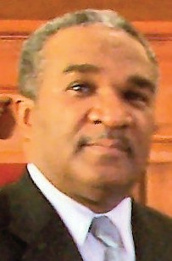Pastor Hudson will preach at New Zion Baptist during its Holy Week observations. He will speak at 7 p.m. April 17. New Zion is at 3991 Longhill Rd.
u
Our annual Good Friday service scheduled for April 18 and 19 has been canceled. The Good Friday Committee thanks everyone who volunteered to be a part of the program, and asks that the Good Friday program be kept in your prayers as the committee at- tempts to carry on the dream and passion of our brother, Dea. Gregory James.

RESURRECTION SUNDAY
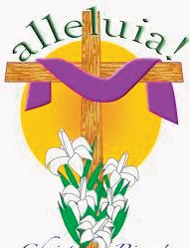St. John will once again join with Grace Baptist Church for the Sunrise Easter serv- ice on April 20 at New Quarter Park. Pastor Stephen Wiley of Grace Baptist will deliver the message.

IN MEMORIAM
Two St. John members recently passed away. Gone to their heavenly home, but not to be forgotten, are:
V Barbara Anne Faulcon, 70, Jan. 7.
V Katherine Pearl Spratley, 93, Jan. 28.

WELCOME, NEW MEMBERS
St. John has welcomed 9 new members to the fam- ily since October.
They are: Mr. Curtis & Mrs. Gail Anderson, Tammy Johnson, Yvette Johnson, Alec Bradley, Elijah Bradley, Chaiese Harris and Mr. Wilbert & the Rev. Doretta Hill.
In addition, 2 members returned to St. John and re- stored their Christianity: Charles Payne Jr. and Bri- anca Stoutingberg.

What’s Inside...
Page 2 ........ Announcements, Accolades, Event Rewind
Page 3 ........ Miscellaneous Photos
Page 4 ........ Warm Nights Photos
Page 5 ........ Sweetheart Breakfast Photos, Upcoming Events
Page 6 ........ Calendar
Page 7 ........ Time With Him column, Deacons Listing
Page 8 ........ Youth Activity Page

YOUTH 4 CHRIST RETURNS
After more than a year away from the choir loft, Youth
4 Christ returned on Feb. 16. The choir is scheduled to
minister through song each third Sunday of the month,
which is now Youth Sunday, as will our Children’s
Choir. Youth 4 Christ is directed by Kenton Jolliff.
Want to join? The choir is currently open to middle-
schoolers through young adults. Rehearsals are held at
6:30 p.m. Thursdays. See Kenton Jolliff or contact the
church office.

AT THE MEETING
It was decided at the March Church Business Meeting that the Youth and Senior ushers will continue to ex- change third and fourth Sundays. The Youth ushers will serve on first and fourth Sundays, and the Senior ushers will serve second, third and fifth Sundays. Youth Sunday is now observed on third Sundays, during which youths will lead the service and provide music.

WOMEN’S DAY
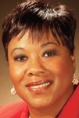Our annual Women’s Day celebration will take place at 11 a.m. Sunday, May 18, with the theme “Women Transformed by the Spirit.” Women are asked to wear pastel-col- ored attire. Guest preacher will be the Rev. Stephanie Credle (pictured) of Sixth Mount
Zion Baptist in Hampton, and the Rev. Cora Arm- strong will direct a special Women’s Day Choir. Women, watch the bulletin for choir rehearsal dates.

PASTOR HUDSON’S ANNIVERSARY
Pastor Walter Hudson will celebrate his 7th anniver- sary as undershepherd of St. John Baptist Church- Williamsburg on June 1. Two services will be held. Guest minister for the 11 a.m. service will be the Rev. Steven Keller of Oak Grove Baptist Church. The after- noon speaker has yet to be determined.

YOUTH DAY & YOUTH REVIVAL
Our annual Youth Day & Recognition of Graduates will take place during the 11 a.m. worship service on Sunday, June 22.
Youth Revival is scheduled for June 23-
25, with Prayer & Praise at 6:30 p.m. and
revival service at 7 p.m.

EVENT REWIND
Just4Girls - 16 youths of the church and community have been busy during the last few weeks. They attended the February Black History Program at the Williamsburg Library, which was presented by storyteller Dylan Pritchett Sr. The group then had dinner at Golden Corral.
As a joint effort with the Greater Williamsburg Women’s Association, the group attended a performance of “Swan Lake,” given by the Moscow Ballet at the Fer- guson Center on March 9, preceded by dinner at the Hi- bachi Grill and Restaurant in Newport News. Special thanks to St. John bus drivers Sis. Terri Savage and Sis. Ruth Allison. Eli Poller served as “the Protector” of the attendees on their trips.
u
The Board of Christian Education sponsored a work- shop on March 22 entitled, “Implementing the Holy Spirit’s Guidance in Our Teaching and Leadership.” Workshop facilitator was Minister Willnette “Cookie” James, founder of Tree of Life International (www.hope- oftroli.org). Minister James presented the “7 Steps to Christlike Behavior,” among other topics. The workshop also included a time of meditation on Psalm 46:10, “Be still and know that I am God.”
Attendees were reminded that “Quietness is the incu- bator for the spirit of revelation.” - Jim Goll

NOTEWORTHY
Now that spring is officially here, it’s time to think about your yard. Don’t
know where to start? William Palmer has opened a new business - In Excellence Lawn Service LLC. Call Palmer at 879-
2067, e-mail palmer198@verizon.net or log on to inexcellencelawnservicellc.com
u
Pvt. Kelsea Woods, granddaughter of Margo Parsons-Bell and daughter of Shellie Willis, graduated from the Marine Corps at Parris Island, S.C., on Feb. 14. She graduated from Combat Training School at Camp Leje- une, N.C., on March 29. Pvt. Woods will now attend her MOS (Military Occupational Spe-
cialty) training class, also at Camp Lejeune. Her MOS is aircraft maintenance administration. A 2012 graduate of Bruton High School, Kelsea was an active member of Youth 4 Christ and participated in several other St. John youth activities.
u
Karla Munden, senior vice president and general au- ditor for Lincoln Financial Group, was nominated as one of the Top 100 Most Influential Blacks in Corporate America. Karla is the niece of Fred and Lynda Harold. She is a fellow of the Life Management Institute and maintains these internal audit-specific certifications: Cer- tified Internal Auditor, Certified Financial Services Audi- tor and Certified in Control Self Assessment. She also serves as a member of the Accounting and Advisory Board at the Martha and Spencer Love School of Busi- ness, Elon University. She holds a bachelor of arts de- gree in accounting from the College of William & Mary and an MBA from the University of Phoenix.

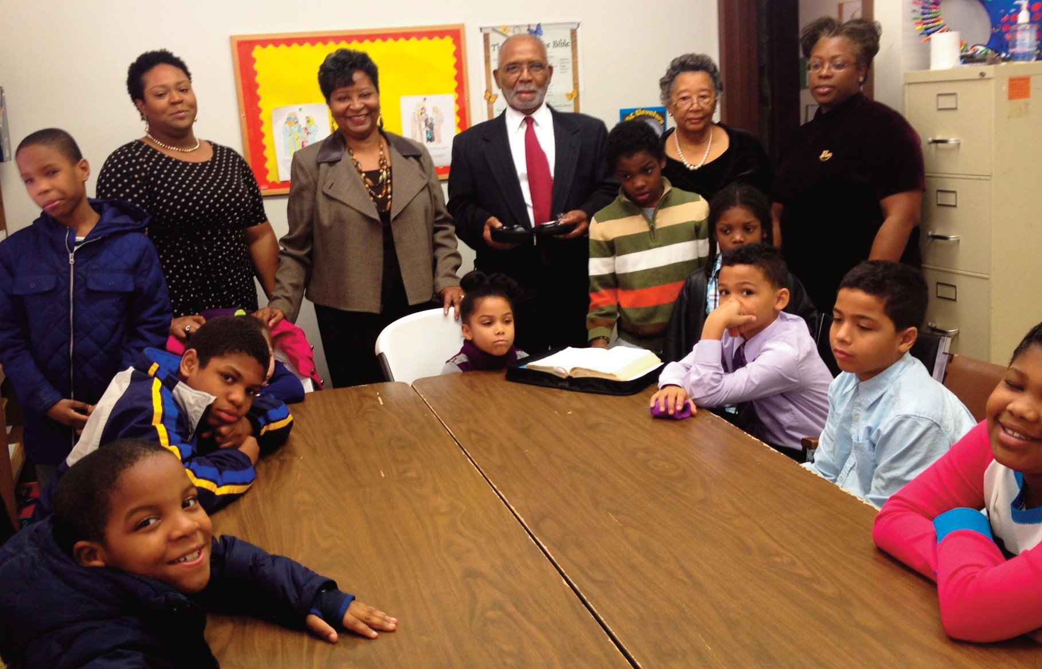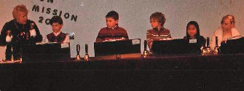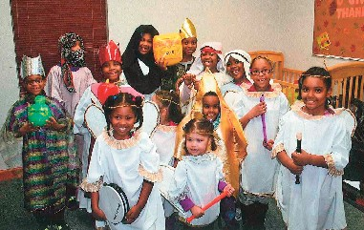Photo submitted by Kenneth Haywood
What is
Communion?
Deacon Fred Kyle and Deaconess Mar- jorie Kyle (standing, third and second from right) recently taught the Elemen- tary Sunday school classes about the meaning of Com- munion. Sunday school for ages 3- adults is held each Sunday at 9:15 a.m. Also pictured with the class are (from left, standing)
Bianca Phillips, Jacquelyn Wright and Marilyn Marsh- Mathis, who work with our youths.

Photos submitted by Marjorie Kyle
Birthday Party for Jesus
Our December Family & Friends Night featured the St. John Children’s Choir (above) and a handbell choir from Williamsburg United Methodist (below). Both groups played and sang songs during a “Birthday Party for Jesus.” Our Family & Friends Nights are open to everyone. They are typically held third Wednesdays of the month, January-May and September-December.

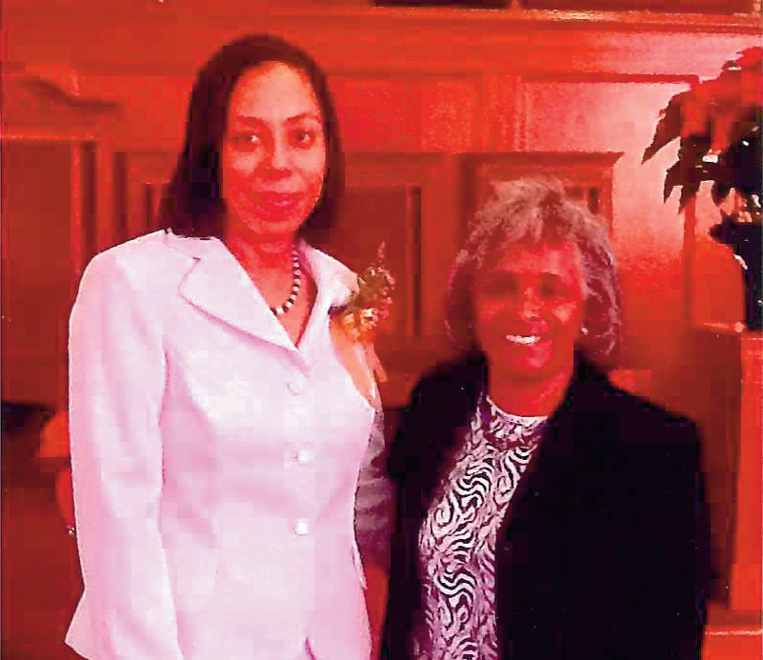Photo submitted by E. Harris Bernard
Mission Sunday
“Oh, the places that Jesus went - Oh, the places that you will go when you follow Him!” thus echoed the Rev. Juanita Graham (above, left) as she blessed St. John’s inaugural Mission Sunday in December. The worship service included a celebration of annual min- istries’ mission activities and the first Sunday of the Advent season. Longtime St. John missionary Dea- coness Geraldine Payne was also honored. Addition- ally, St. John welcomed Gerri Polk (above) and Arnold Polk of the Polk Building Ministries, a world mission. St. John has proposed that Mission Sunday become an annual event.

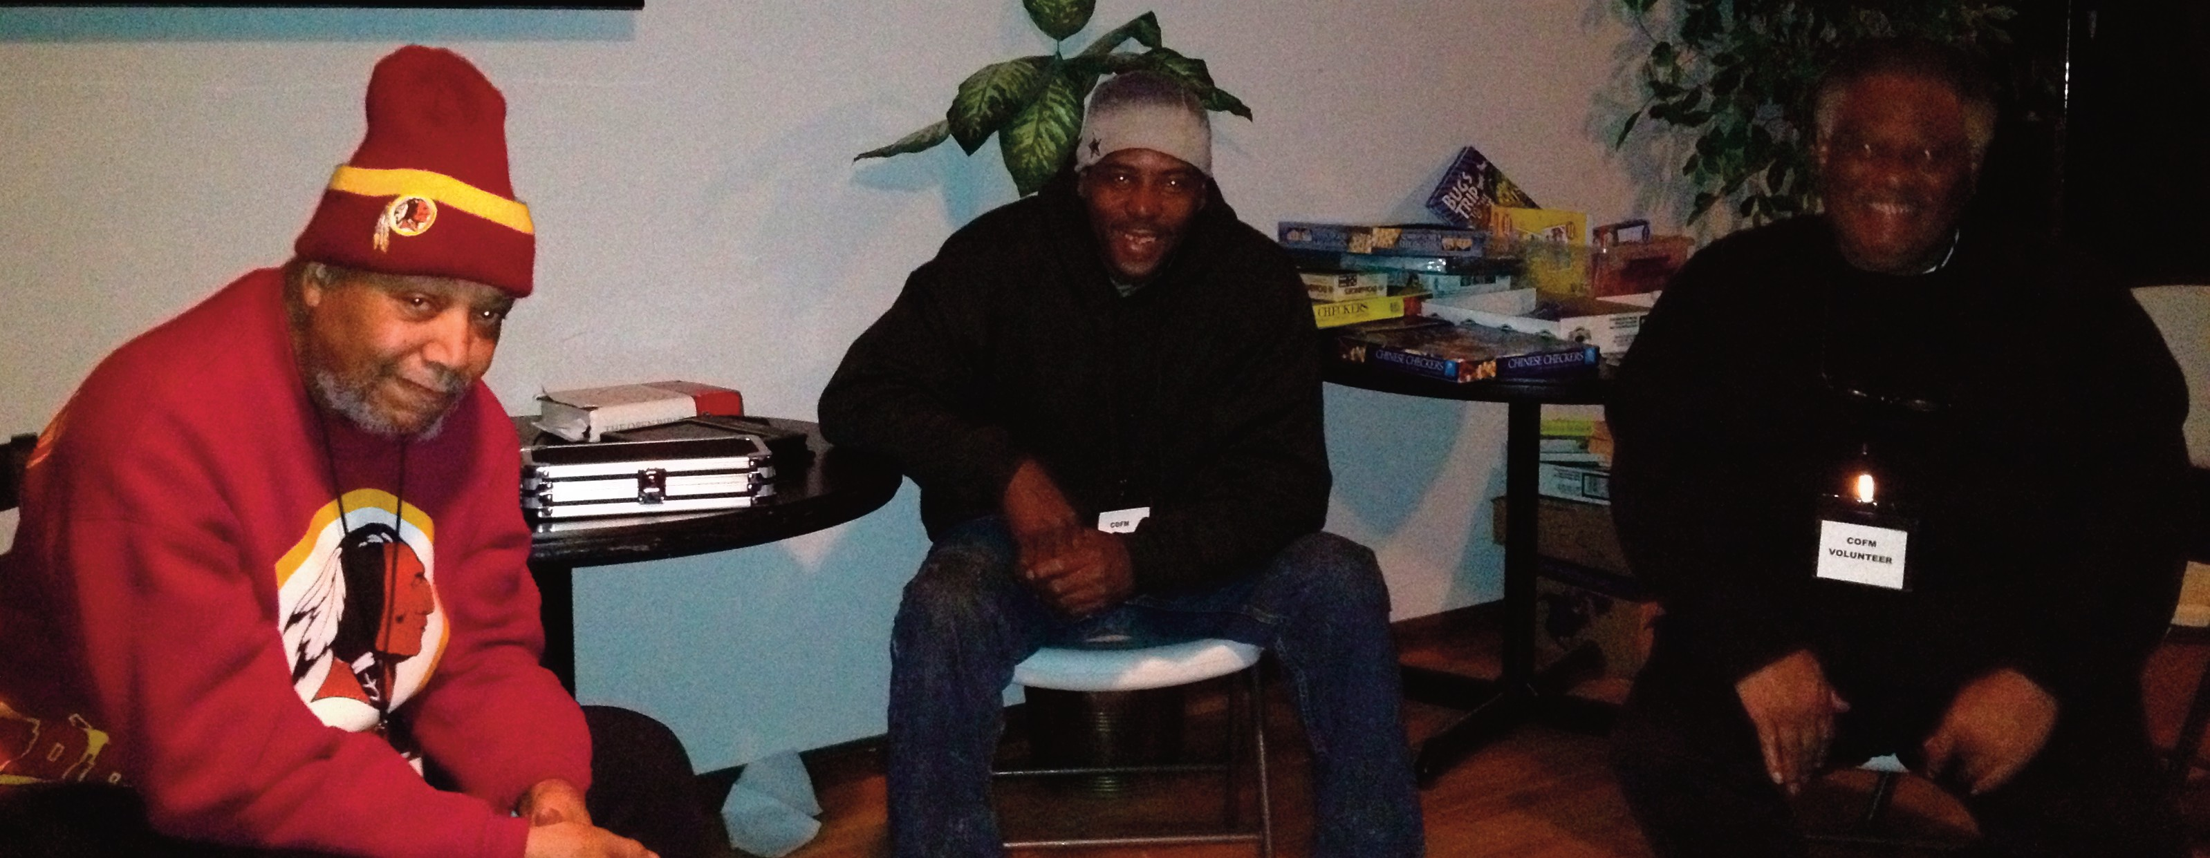Warm
Nights

St. John was once again blessed to be able to host a session of “Warm Nights.” From Jan. 19 through Jan.
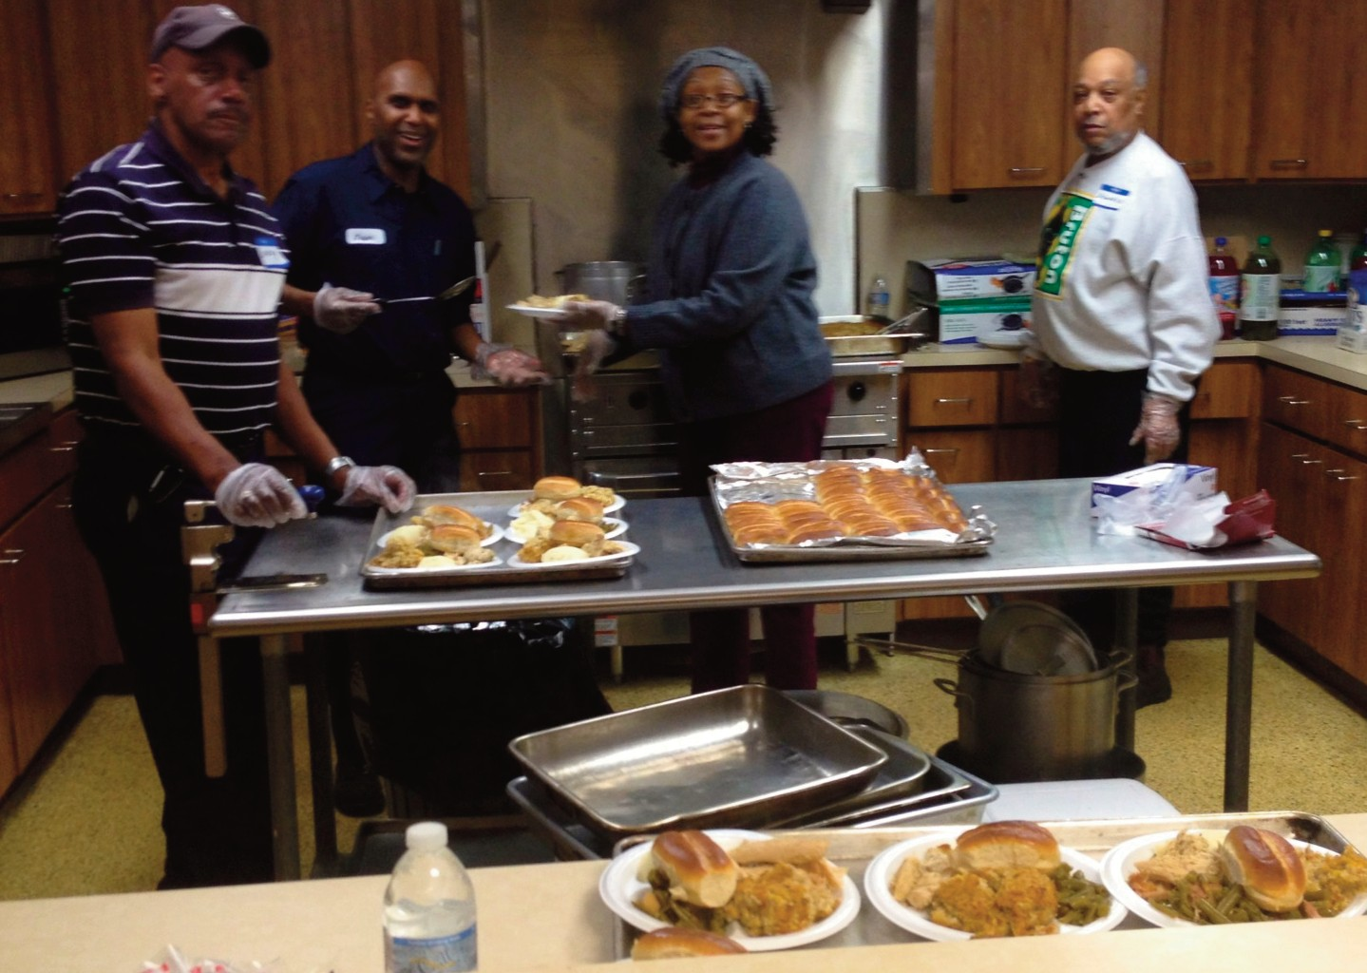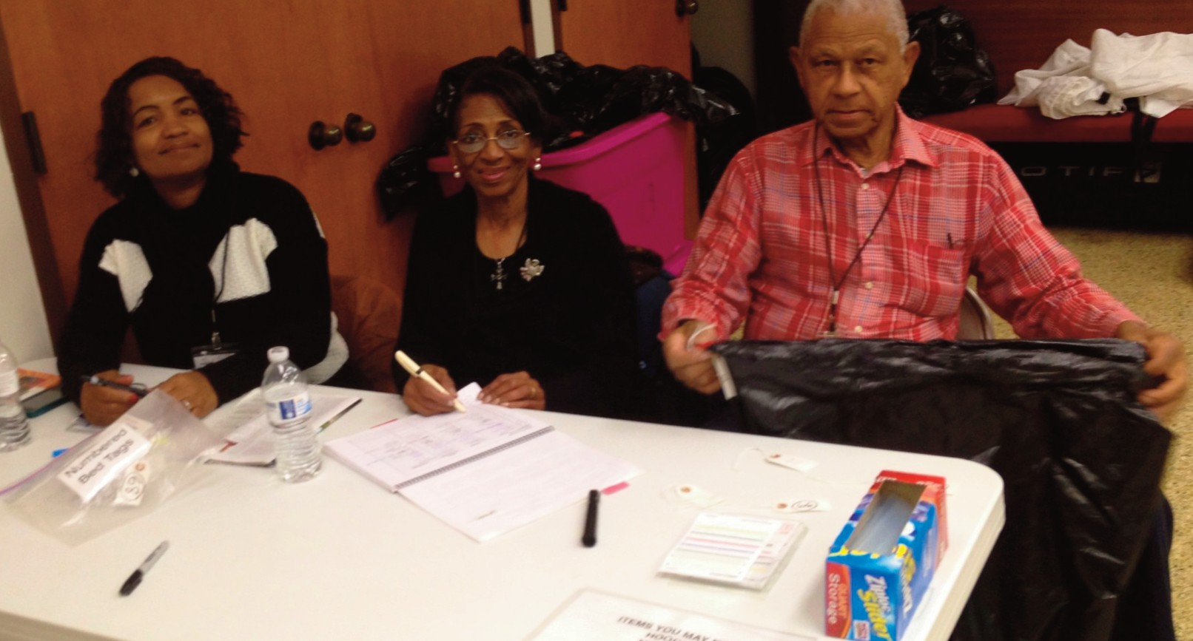26, individuals in the com- munity without homes were provided a warm place to lay their head and receive dinner and breakfast. Don- ald Epps, the Rev. Richard
Williams and Charles Wash- ington (top, right) volun- teered as night chaperones. The Men’s Brotherhood, in- cluding Larry Williams, Jasper Edmonds and Donald Epps, along with Sis. Ethel Smith, (right) helped pre- pare meals.

Young men of St. John also as- sisted with nightly setup. Pictured are Shaquan Muse, Kalobe Sad- dler and Jordan Butler, who pre- pared linens for storage.

Volunteers Joyce Ashlock, Verma Lewis and Dea. Joseph Ed- monds (right) were on hand to receive our guests for intake and baggage storage.

Photos submitted by Kenneth Haywood

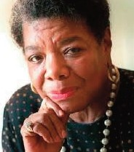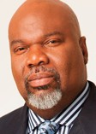UPCOMING EVENTS
u The movie “Mandela: Long Walk to Freedom” shown at the Kimball Theatre in Merchants Square April 1-4 at 6 and 8:30 p.m. Tickets are $8 and $7.
u NAACP ACT-SO local competition, featuring the sciences, performing arts, visual arts and business, will be held at 9 a.m. April 5 at First Baptist Church. 253-0841.
u “Messiah,” by G.F. Handel, 5 p.m. April 12 at Williamsburg United Methodist, featuring the Easter portion and the Handel Chamber Orchestra & Chorus. Free. 229-1771
u Dr. Maya Angelou will speak at the College of William & Mary at 7:30 p.m. April 15. Angelou, hailed as one of the greatest voices of contempo- rary black literature, will speak as the centerpiece of I Am William & Mary Week. Tickets: 221-
3340.
u The Good News Jail & Prison Ministry will sponsor Hope Beyond the Walls’ Annual Banquet at 6:30 p.m. Fri- day, April 25, at Fort Magruder Hotel & Conference Center. Ticket reservations are required, $23. Deadline to purchase tickets is April 21. Call 303-9446 or 229-0759.
u The Virginia Peninsula Foodbank will present the Harlem Wizards at Heritage High School at 6 p.m. April 4. Student tickets are $7, adults $12. Call 596-7188.
u Community for a Cure Relay for Life team will hold its fundraiser Fish Fry on April
26. Dea. Fred Kyle is team captain.
u The York-James City-Williamsburg NAACP will present its 35th annual Life Membership Banquet on April 26 at the Williamsburg Lodge & Conference Center. Silent auction at 5 p.m., dinner and program at 6:30. Keynote speaker is Dr. William Harvey, president of Hampton University. Tickets: 229-3113.
u Hampton University Ministers’ Confer- ence is celebrating its 100th year. The conference will be held June 1-6 at Hampton University. Bishop T.D. Jakes will be the conference preacher. Registration information is available in
the church office.
u 147th Annual Session, Virginia Baptist State Convention Inc. will be held May 12-15 in Williamsburg. Preregistrations due April 30. www.thevbsc.net
u Williamsburg Reunion 2014 is set for June 7-8 in Williamsburg. For a list of planned activities, log on to www.WilliamsburgReunion.com or call 810-3123. Regis- tration deadline May 28. Open to everyone who lived in or around Williamsburg, James City and York’s Bruton Dis- trict in the year 1974 or earlier.

Sweetheart
Breakfast

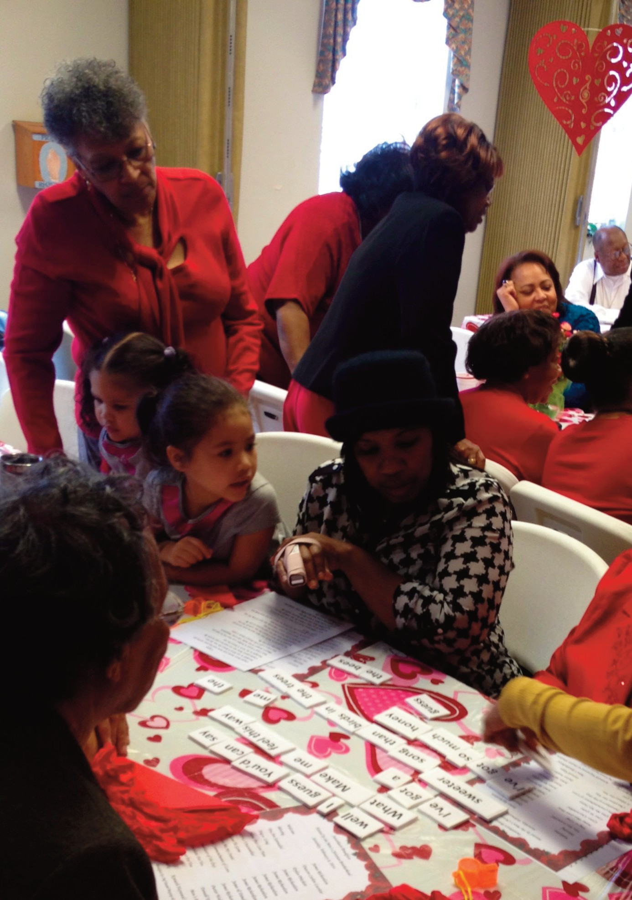The Men’s Brotherhood sponsored the annual Sweetheart Breakfast in February. The morning included delicious food, games, including Lyrics Unscrambled (pictured), a serenade and other special activities. Each woman received a red carna- tion, along with Pastor Hudson’s homemade chocolate candy!

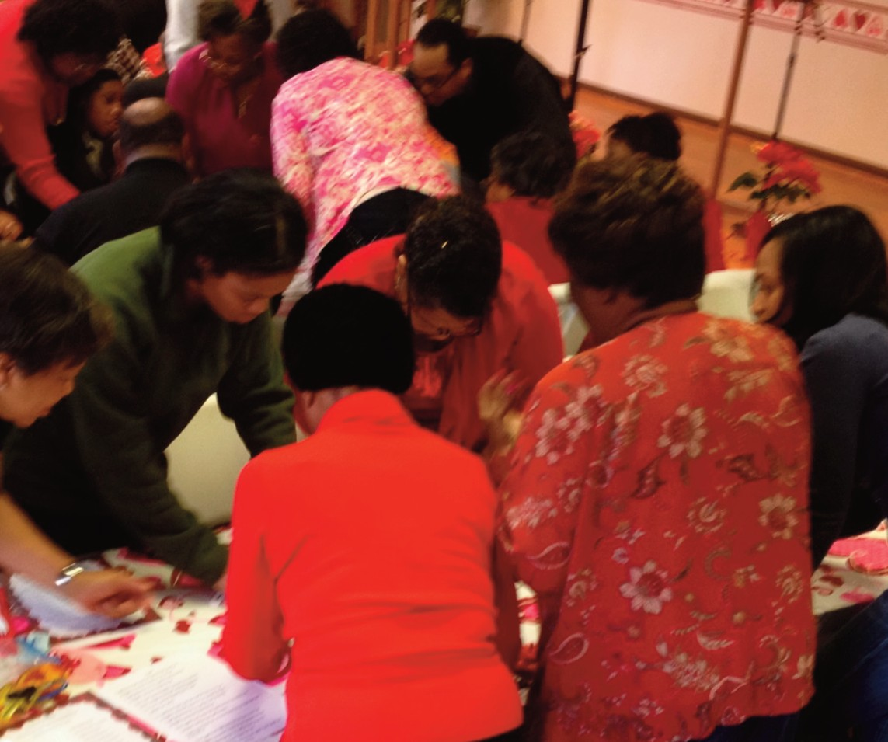Photos submitted by Kenneth Haywood

~ Mark Your Calendar ~

April
5 - Brotherhood Fellowship Breakfast, 8 a.m.
6 - Senior Usher Board 75th Anniversary observed
12 - Church Council Meeting, 9 a.m.
13 - Palm Sunday - when Jesus made His triumphal entry into Jerusalem
13 - Senior Choir 75th Anniversary, Crusaders Male Chorus of Hampton in concert, 4 p.m.
14-18 - Holy Week services, sponsored by the Tri-County Pastor’s Council
16 - Family & Friends Night, 6 p.m.
17 - Maundy Thursday - observed as commemoration of the Last Supper
17 - Pastor Hudson speaks at New Zion Baptist during Holy Week Observation, 7 p.m.
18 - Good Friday - crucifixion of Jesus Christ commemorated
20 - Easter Sunday - He Lives!
20 - Easter Sunrise Service with Grace Baptist, 6:15 a.m. New Quarter Park
26 - Health Ministry Health Fair, with a focus on children and youths, 9 a.m.
26 - Board of Christian Education workshop, 10 a.m.
27 - Just 4 Girls “Character,” 1 p.m.

May
4 - All reports/requests for the May 8 Church meeting are due
10 - Men’s Christian Brotherhood Pre-Mother’s Day breakfast, 9 a.m.
11 - Happy Mother’s Day!
12-15 - 147th annual Session of the Virginia Baptist State Convention - Williamsburg
18 - Women’s Day, 11 a.m.
18 - Just 4 Girls - “Companionship/Women’s Day,” 2 p.m.
21 - Family & Friends Night, 6 p.m.
25 - Memorial Sunday
26 - Memorial Day
31 - Sunday School Union, 9 a.m. at Little Zion - Grove

June
1 - All reports/requests for the June 5 Church meeting are due
1 - Pastor Hudson’s 7th anniversary, services at 11 a.m. and 3 p.m.
2-6 - Hampton University Ministers’ Conference
14 - Adult Ministry Pre-Father’s Day Breakfast, 9 a.m.
15 - Happy Father’s Day!
15 - Trinity Sunday
15 - National Baptist Congress of Christian Education conference, Dallas Texas
22 - Scholarship Offering, 11 a.m.
22 - Youth Day & Recognition of Graduates, 11 a.m.
23-25 - Youth Revival Services, 6:30 p.m.

Busyness is not Godliness... 2 Timothy 2:15 - Study to shew thyself approved unto God, a workman that needeth not to be ashamed, rightly dividing the word of truth.

How do you hug God?
Let me start by saying, “I am not a hugger.” I am much better than I used
to be, but I don’t go around

J Time With Him

hugging everyone ran- domly. If someone looks
like he or she needs a hug, I usually ini- tiate one. I realize that, if I call myself a Christian, I am to show the love of Christ at all times. I choose to show my love for others in other ways, not al- ways a hug. He’s not finished with me yet, so the day may come when I offer hugs without a reason.
But when a person does something nice for someone, most folk naturally want to give that person a hug and say “thank you.” So after all that God has
already done for us, we ought to want to give Him a huge hug every day He wakes us up. Since we can’t physically hug Him, we should hug Him in other ways.
Hug God with your praise - in spirit and in truth - (John 4:24), hug Him by obeying and embracing His commands (Exodus 20), hug Him by putting Him first in your life (Matthew 6:33), hug Him by showing agape - unconditional
- love for your fellow man (John
13:34).
If none of those work for you, close
your eyes, talk to God through prayer
and meditation, and just envision
squeezing Him tight!
I want to give God a big ol’ hug for
all He has done for me and for bringing
me thus far. I have a ways to go, but I
know Who is in charge of my future.
This brings to mind one of my fa- vorite songs, “When I Think About the Lord.”
When I think about the Lord,
How He saved me, how He raised
me,
How He filled me with the Holy
Ghost, how He healed me to the utter-
most.
When I think about the Lord,
How He picked me up, turned me
around, placed my feet on solid ground.
It makes me wanna shout: Hallelu-
jah! Thank you, Jesus!
Lord, You’re worthy
of all the glory, of all
the honor and all the
praise.

Dietra Baytop, writer/acting editor

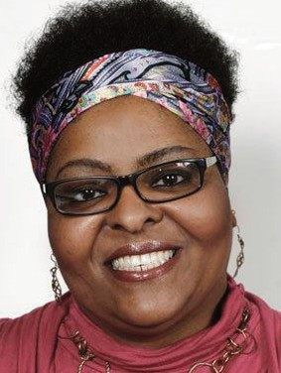St. John Deacons

Deacon Name Area(s) Covered Phone No.

Dea. Brady Graham, chair Toano, City of Williamsburg, Norge 229-2649

Dea. Frederick Kyle, vice chair Penniman Road, Oak Drive, Government Road,
James Terrace, York Terrace 259-1176

Dea. Joseph Edmonds Carver Gardens 229-6149

Dea. Curtis Lassiter Sr. Country Club Acres & Yorktown 220-0580

Dea. David Mack Sr. Springfield Terrace & Queens Creek Road 303-9446

Dea. James Mitchell Grove, Newport News, Hampton, Gloucester &
Tidewater 871-4233

Dea. Carlon Lassiter Grove, Newport News, Hampton, Gloucester &
Tidewater 570-4271

Dea. Bernard Payne Jr. Penniman Road, Oak Drive, Government Road,
James Terrace & York Terrace 220-4282

Youth Activity Page

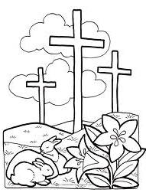Children’s Bible Quiz
(answers at bottom of page)

1. What was the first thing that God created?

2. Who was thrown into a lions' den by King Darius? This person prayed to God 3 times a day.

3. What was the boat Noah built called?

4. How many of each type of animal did Noah have on the ark?

5. This prophet was swallowed by a fish.

6. Who received the 10 commandments from God?

7. What are we told to do in the 5th commandment?

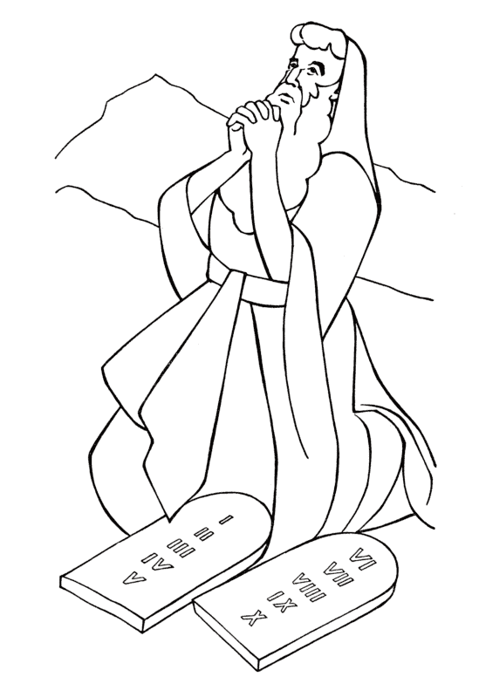8. What was the name of Moses' brother?

raisingourkids.com

God
is
Love!

1. Light
2. Daniel
3. An ark
4. Two
5. Jonah
6. Moses
Quiz Answers:

God gave Moses the

7. Honor our father and mother
8. Aaron
Ten Commandments

raisingourkids.com

